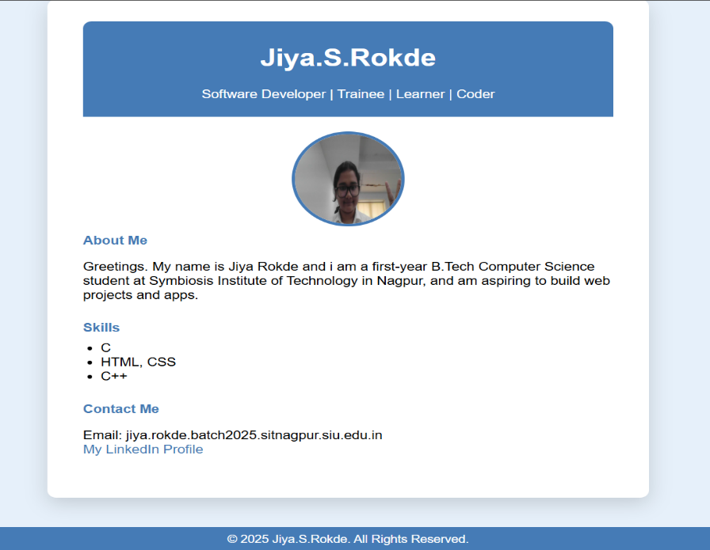
Practical:- To create portfolio webpage using html css

<!DOCTYPE html>
<html lang="en">
<head>
<meta charset="UTF-8">
<title>Jiya.S.Rokde</title>
<style>
body {
background: #e6f0fa;
font-family: Arial, sans-serif;
margin: 0;
padding: 0;
}
.container {
width: 600px;
background: #fff;
margin: 40px auto;
border-radius: 10px;
box-shadow: 0 8px 24px rgba(0,0,0,0.15);
padding: 30px 40px;
}
.header {
text-align: center;
background: #457bb6;
color: white;
padding: 10px 0 20px 0;
border-radius: 10px 10px 0 0;
}
.profile-pic {
width: 120px;
height: 120px;
border-radius: 50%;
margin: 20px auto 10px auto;
display: block;
border: 4px solid #457bb6;
}
h2 {
margin: 10px 0 5px 0;
}
.section {
margin-bottom: 25px;
}
.section-title {
font-weight: bold;
color: #457bb6;
margin-bottom: 8px;
}
ul {
margin: 0;
padding-left: 20px;
}
a {
color: #457bb6;
text-decoration: none;
}
.footer {
text-align: center;
background: #457bb6;
color: #fff;
padding: 8px;
border-radius: 0 0 10px 10px;
margin-top: 15px;
font-size: 0.9em;
}
</style>
</head>
<body>
<div class="container">
<div class="header">
<h1>Jiya.S.Rokde</h1>
<span>Software Developer | Trainee | Learner | Coder</span>
</div>
<!-- Replace src with your image path -->
<img src="C:\Users\Dell\Documents\jiya.jpg" class="profile-pic" alt="Jiya.S.Rokde">

<div class="section">
<div class="section-title">About Me</div>
<p>Greetings. My name is Jiya Rokde and i am a first-year B.Tech Computer Science student at Symbiosis Institute of Technology in Nagpur, and am aspiring to build web projects and apps.</p>
</div>
<div class="section">
<div class="section-title">Skills</div>
<ul>
<li>C</li>
<li>HTML, CSS</li>
<li>C++</li>
</ul>
</div>
<div class="section">
<div class="section-title">Contact Me</div>
<p>
Email: jiya.rokde.batch2025.sitnagpur.siu.edu.in<br>
<a href="https://www.linkedin.com/in/jiya-rokde-358b96376/">My LinkedIn Profile</a>
</p>
</div>
</div>
<div class="footer">
&copy; 2025 Jiya.S.Rokde. All Rights Reserved.
</div>
</body>
</html>

